
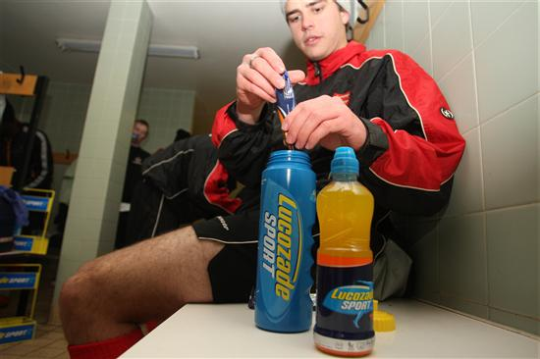
LSPL Weekly Newsletter
Frozen Pitches hit the LSPL
Dear LSPL player,
With winter biting hard all last week, only 15 fixtures in the LSPL were able to be played, but there were still plenty of goals and tightly contested matches. JACK POUNDER started 2009 in the same way he finished 2008, scoring another 4 as HORDEN CW won 7-2.
There were 3 other hat-trick heroes in the LSPL last weekend: JAMES SMITH from CLAPTON RANGERS, MESUT ERZURUMLUOGLU from ANATOLIA and BEN PURCELL from STRATTON FC, who all guided their respective teams to victory.
EDEN GROVE had a comfortable 5-0 win sharing the goals amongst 5 different scores - a true team effort!
Yours in Football,
The LSPL Team
Ladies Week - Top 5
 | TEAM | P | W | D | L | PTS
1 | Tipton Town Ladies FC | 3 | 3 | 0 | 0 | 303.67
2 | Wandgas Ladies | 7 | 4 | 2 | 1 | 201.57
3 | Hutton Ladies FC | 8 | 4 | 1 | 3 | 163.50
4 | Kent Magpies Ladies FC | 10 | 4 | 3 | 3 | 150.70
5 | Merthyr Tydfil LFC | 8 | 2 | 0 | 6 | 72.88
Click here to see the full LSPL table

LSPL Leading Scorers - Teams
These teams have been banging in the goals for fun all season; how does your team compare?
 | TEAM | GOALS | AV GOALS
1 | Horden CW | 65 | 5.42
2 | Codicote FC | 62 | 3.40
3 | Dunes FC | 60 | 7.50
4 | Ringwood Town | 48 | 2.18
5 | Kelvedon Hatch | 46 | 3.83

Click here to see the Indivdual Golden Boot Table

Dunes FC fall foul of 'Manager of the Month Syndrome'  After being crowned winners of the LSPL Top at Christmas competition, winning VIP Barclays Premier League tickets for the squad, DUNES FC were held to a draw last weekend blowing the race for the inaugrual LSPL title wide open. Manager JOHN SANKEY said "no sooner had I told the team we had won the tickets then we go and drop our first point of the season in a dreadful 1-1 draw with a team we beat 8-0 last time out - its a funny old game"  See the full LSPL table | 

 | May 2009 Charity Tournament  COLIN HARE from CS UNITED is organising a charity football tournament in May, and is on the lookout for LSPL teams to enter and play each other, to see if those LSPL league positions are justified! All proceeds will go towards funding a trip to Asia to build homes for the poor. The Tournament will take place over the early May Bank Holiday weekend (2nd May) at Egham Sports Centre in Surrey and will follow a World Cup format. Female teams are most welcome to enter to. If your team is interested in playing or for further details of the tournament, please e-mail Colin directly colinhare@talktalk.net  Click here for details of the charity

LSPL talkSPORT Coverage  Every week the movers and shakers in the Lucozade Sport Performance League are followed closely on talkSPORT radio. You can tune in on Thursday night between 7-10pm for evening show "Kick off" with Danny Kelly. Then on Sunday afternoon talkSPORT will catching up with the latest pitch side action from the LSPL between 2-7pm, followed by an LSPL weekly review within "The Sports Bar" show from 7-10pm hosted by Andy Goldstein and LSPL expert panel member Jason Cundy.  If you don't manage to tune into the shows then don't worry. We're uploading the latest LSPL talkSPORT podcasts each week so you can catch up right here.  Click here for the latest from talkSPORT or for any past podcasts | 

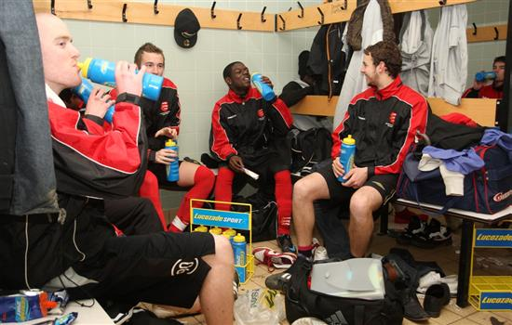
LSPL Weekly Newsletter
Week 5: The Christmas Run-In
Dear LSPL player,
There were goals galore for the LSPL teams last weekend. AFC CHESTER kick-started their season with a much needed 14-0 win over Blackburn Rovers. BREWERS FC managed to score 8, while both NORTH HERTS CELTIC and GRANGEFIELD OLD BOYS enjoyed 7-2 victories over their respective opponents. The match of the week involved JUNCTION FC as they won by the odd goal in 9 edging out Brown Edge, with their local hero and top scorer CHAZINHO claiming a brace.
Yours in Football,
The LSPL Team
Click here to see the full LSPL League Table
League Snapshot: Battle for Top at Christmas
 | TEAM | P | W | D | L | PTS
1 | Dunes FC | 7 | 7 | 0 | 0 | 307.71
2 | Drumchapel United FC | 6 | 6 | 0 | 0 | 303.17
3 | Tipton Town LFC | 2 | 2 | 0 | 0 | 303.00
4 | Horden CW | 9 | 8 | 1 | 0 | 282.56

Hat-trick Heroes
 | PLAYER | TEAM | GOALS | AV GOALS
5 | Jake McGarry | Brewers FC | 14 | 1.75
9 | Kev Brown | Grangefield Old Boys | 10 | 1.25
15 | Mesut Erzurumluoglu | Anatolia FC | 10 | 1.11
 | Stephen Norman | AFC Chester | 5 | 1
108 | Danny Bailey | Brewers FC | 4 | 0.50

Goals aplenty again in the LSPL this week, above are a selection of hat-trick heroes from last weekend’s fixtures

Will you be the Most Improved LSPL team?  Although we know that winning the LSPL title is the ultimate goal for all of you, we want to make sure that there’s plenty to play for this season, even if you’re in the bottom half of the table. That’s why we offering an amazing prize to the MOST IMPROVED team in 2009. We’re going to keep a close eye on your results at the turn of the year and reward the team that makes the greatest improvement in the second half of the season. So, don’t lose heart if you’re not in the running for the title – every performance counts!  The lucky winners will get the chance to play in a Barclays Premier League club stadium at the end of the season, because we want to show you that Lucozade Sport is committed to helping you be more Premier League.  Click here to see the LSPL Team Challenges | 

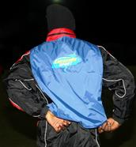 | New LSPL Expert of the Month: Tottenham Hotspur's Sam Erith  Losing key players to injury is a nightmare scenario for all teams, from the Barclays Premier League through to the Sunday leagues. Not only do we want to help amateur teams to improve their performance on the pitch but equally important is making sure that they can always get out on the field in the first place. That’s why we enlisted the help of SAM ERITH of TOTTENHAM HOTSPUR FC to tell us more about injury prevention and conditioning.  Sam took the players of the University of Essex (Reserves) through their paces in the latest instalment of the LSPL Expert Panel. Players at all levels pick up a lot of small tears or strains and these are often injuries that can be avoided by doing the correct exercises to strengthen certain muscles, having adequate fitness levels and getting your nutrition and hydration strategies right. Sam shares some insights into the kind of drills and preparation used by Barclays Premier League players, but he also educates amateur players about what they can do in their own time without the professional facilities and equipment.  Be sure to check out the session and download the training drills here

The LSPL Cup, your last chance to enter  January will see the launch of the LSPL Cup, a new competition which will take place alongside the LSPL. 512 teams will be selected at random and, in the same way as the LSPL, performances in each team's own league fixtures will determine their success. The competition will kick-off on the 31st of January and each week teams will be drawn at random to face each other each in a knockout format until only eight remain.  The finalists will take part in a play off at Carrington, training ground of Barclays Premier League and UEFA Champions League holders Manchester United. To take your LSPL experience to the next level by entering your team in the LSPL Cup click the link below.  Click here to enter your team | 